Name: P.Harshika
Branch: CSE-AIML
Course: AI Assisted coding
Enroll no: 2503a52703

Task Description #1 (Privacy & Security in File Handling)
Task: Use an AI tool to generate a Python script that stores user data (name, email, password) in a file.
Analyze: Check if the AI stores sensitive data in plain text or without encryption.
Expected Output:
Identified privacy risks.
Revised version with encrypted password storage (e.g., hashing).
Prompt:
Create a simple Python program that stores user name, email, and password in a file. Identify the privacy risk of storing the password in plain text and then modify the program to store the password securely using SHA-256 hashing.
Code:
import hashlib
name = input("Enter your name: ")
email = input("Enter your email: ")
password = input("Enter your password: ")
# Hash the password
hashed_password = hashlib.sha256(password.encode()).hexdigest()
with open("user_data.txt", "a") as file:
file.write("Name:"+name+"\n")
file.write("Email:"+email+"\n")
file.write("Password hash:"+hashed_password+"\n")
print("User data stored securely.")
output:
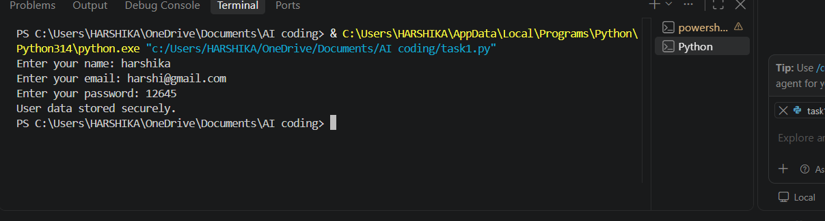
Task Description #2 – Fair Decision Logic
Task: Prompt an AI tool to generate a scholarship eligibility checker based on academic score, family income, and location. Examine whether the logic unfairly favors or disadvantages any group.
Expected Output-2:
Code snippet with observations on fairness.
Brief explanation (3–4 sentences) suggesting improvements to ensure equitable decision-making.
Prompt:
Create a simple Python scholarship eligibility checker using academic score, family income, and location. Generate the Python code and output. After the code, identify any fairness issues in the decision logic. Also provide a brief 3–4 sentence explanation suggesting improvements to make the scholarship decision fair and equitable for all students.
Code:
score = int(input("Enter your academic score: "))
income = int(input("Enter family income: "))
location = input("Enter your location (urban/rural): ")
if score>=75 and income<=300000 and location=="rural":
print("eligible for the scholarship.")
else:
print("not eligible for the scholarship.")
print("/nFairness observations:")
print("The logic may be unfair because it gives preference to rural students.")

print("\nExplanation:")
print("Scholarship decisions should focus mainly on academic performance and financial need.")
print("Location should not automatically disadvantage students from urban areas.")
print("If location is considered, it should have a clear and justified purpose.")
print("The criteria should be transparent and applied equally to all students.")
output:
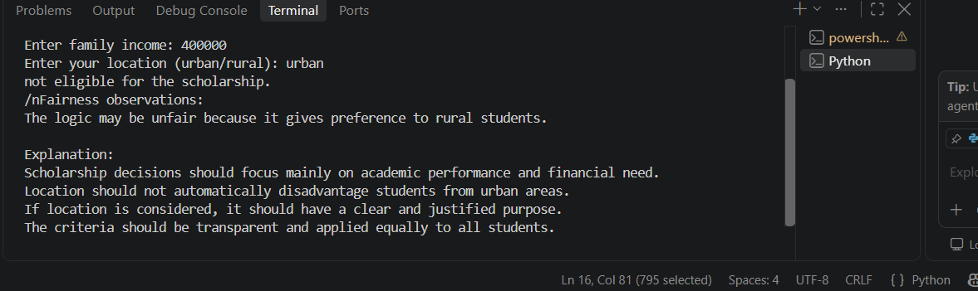
Task Description #3 (Transparency in AI-Based Admission System)
Task: Use an AI tool to generate a Python program that predicts whether a student should be selected or rejected for admission based on factors such as entrance exam score, academic marks, and other relevant admission criteria.
Analyze: Check whether the AI system provides a clear and understandable reason for its admission decision.
Expected Output:
- Identified transparency risks.
- Example of an admission decision where the AI gives no explanation.
- Revised version that provides a clear reason for selecting or rejecting the student.
- Example output showing the important factors that influenced the AI's decision.
Prompt:
Create a simple Python admission system that selects or rejects a student based on entrance exam score and academic marks. First create a version that gives only the admission decision without any explanation. Identify the transparency risk in this version. Then create a revised version that provides a clear reason for the decision and shows the important factors that influenced the admission decision. Provide example outputs for both versions.
Code:
entrance_score = float(input("Enter entrance exam score: "))
academic_marks = float(input("Enter academic marks: "))

if entrance_score >= 70 and academic_marks >= 75:
print("Selected for admission")
print("Reason:")
print("- Entrance exam score meets the required 70.")
print("- Academic marks meet the required 75.")
print("Important factors: Entrance exam score and academic marks.")
else:
print("Rejected for admission")
print("Reason:")

if entrance_score < 70:
print("- Entrance exam score is below 70.")

if academic_marks < 75:
print("- Academic marks are below 75.")

print("Important factors: Entrance exam score and academic marks.")
output:
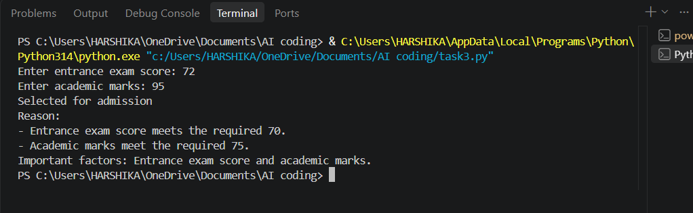
Task Description #4 – Ethical Scoring System
Task: Generate an employee performance evaluation system using inputs such as project completion rate, teamwork score, and attendance. Analyze the scoring logic for any unethical weighting or hidden bias.
Expected Output-4:
Python code along with a written analysis identifying whether the evaluation criteria are balanced and justifiable.
Prompt:
Create a simple Python employee performance evaluation system using project completion rate, teamwork score, and attendance. Calculate a final performance score using clear and reasonable weights. Display the performance rating and explain the scoring criteria. After the code, analyze whether the evaluation criteria are balanced and justifiable, and identify any unethical weighting or hidden bias. Suggest improvements to make the evaluation fair and transparent.
Code:
completion = float(input("Enter project completion rate (%): "))
teamwork = float(input("Enter teamwork score (%): "))
attendance = float(input("Enter attendance (%): "))
# Weighted scoring
final_score = (completion * 0.5) + (teamwork * 0.3) + (attendance * 0.2)

print("\nFinal Performance Score:", final_score)

if final_score >= 80:
print("Performance Rating: Excellent")
elif final_score >= 60:
print("Performance Rating: Good")
else:
print("Performance Rating: Needs Improvement")

print("\nScoring Criteria:")
print("Project Completion: 50%")
print("Teamwork: 30%")
print("Attendance: 20%")

print("\nEthical Analysis:")
print("The criteria are reasonably balanced because performance, teamwork, and attendance are all considered.")
print("However, project completion has the highest weight, which may disadvantage employees working on complex projects.")
print("The weights should be reviewed regularly and applied equally to all employees.")
print("Performance evaluations should also include a fair review process to reduce hidden bias.")
output:
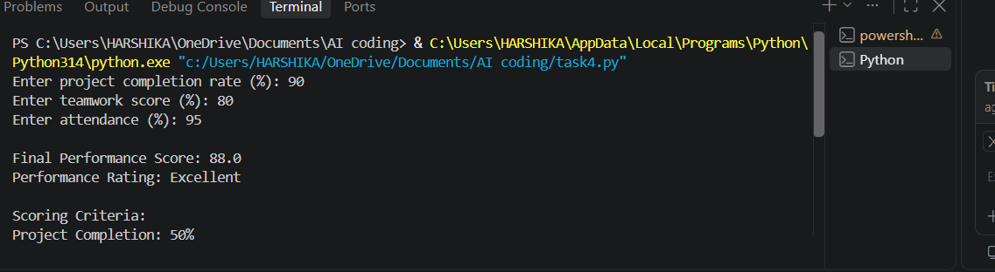
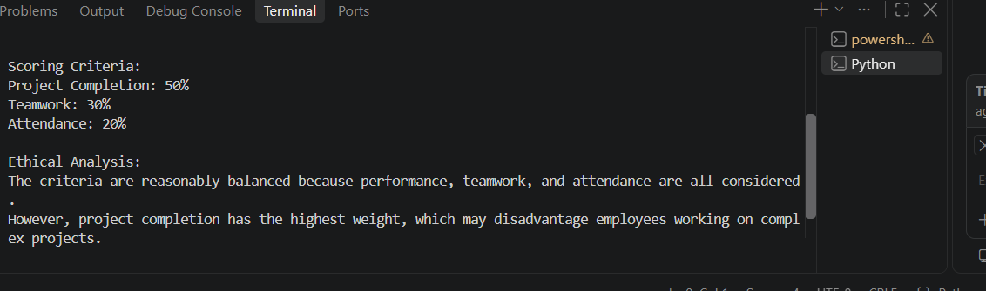
Task Description #5 – Accessibility and Inclusiveness
Task: Use an AI tool to generate a user feedback form application. Review whether the language and options provided are inclusive and accessible to diverse users.
Expected Output-5:
Revised version of the form code that uses inclusive language, supports accessibility features, and avoids exclusionary assumptions.
Prompt:
Create a simple Python user feedback form application. Review the form for inclusive language, accessibility, and exclusionary assumptions. Then provide a revised version of the Python code that uses gender-neutral and inclusive language, provides clear options including "Prefer not to say" and "Other", uses simple readable prompts, and allows users to give feedback without assuming their identity or abilities. Also explain briefly how the revised form improves accessibility and inclusiveness.
Code:
print("===== User Feedback Form =====")

name = input("Enter your name (optional): ")

print("\nHow would you rate your experience?")
print("1. Excellent")
print("2. Good")
print("3. Average")
print("4. Poor")
rating = input("Enter your choice (1-4): ")

print("\nHow would you describe yourself? (Optional)")
print("1. Woman")
print("2. Man")
print("3. Non-binary")
print("4. Other")
print("5. Prefer not to say")
identity = input("Enter your choice (1-5): ")

feedback = input("\nPlease share your feedback (optional): ")

print("\n===== Feedback Submitted =====")
print("Thank you for sharing your feedback.")
print("Your responses will help us improve our service.")

print("\nAccessibility and Inclusiveness:")
print("- Name and identity questions are optional.")
print("- Gender-neutral and inclusive options are provided.")
print("- 'Other' and 'Prefer not to say' options avoid exclusion.")
print("- Simple and clear language is used.")
output:
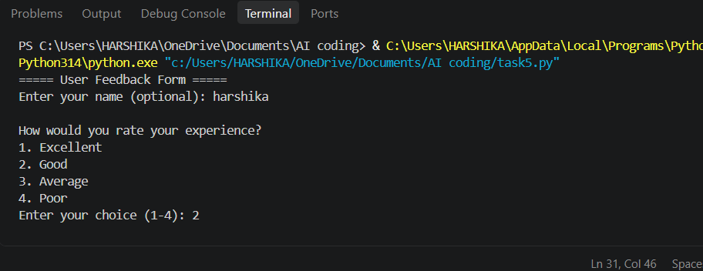
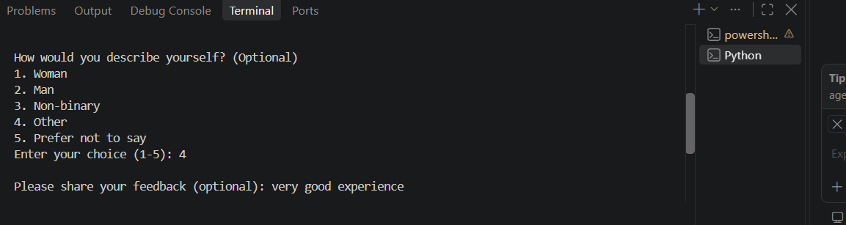
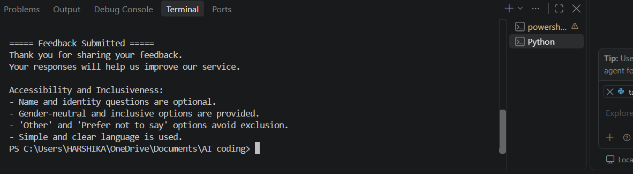
Task Description #6 (Fairness in Loan Approval System)
Task: Use an AI tool to generate a Python program that predicts whether a person should be approved or rejected for a loan based on information such as income, age, employment status, credit score, and loan amount.
Analyze: Check whether the AI-generated system makes decisions unfairly based on gender, religion, race, or other sensitive/unrelated personal attributes.
Expected Output:
- fairness and discrimination risks.
- Examples showing how biased data or rules can lead to unfair loan decisions.
- Revised version that makes loan decisions based on relevant financial factors rather than sensitive attributes.
- Brief explanation of how the revised system improves Identified fairness.
Prompt:
Create a simple Python loan approval system using income, age, employment status, credit score, and loan amount. Analyze whether using sensitive attributes such as gender, religion, or race can cause unfair or discriminatory loan decisions. Give examples of how biased rules can lead to unfair decisions. Then create a revised loan approval system that does not use gender, religion, race, or other sensitive attributes and makes decisions only using relevant financial factors. Include example outputs and a brief explanation of how the revised system improves fairness.
Code:
income = float(input("Enter annual income: "))
age = int(input("Enter age: "))
employment = input("Enter employment status: ")
credit_score = int(input("Enter credit score: "))
loan_amount = float(input("Enter loan amount: "))

if income >= 300000 and credit_score >= 700 and employment.lower() == "employed" and loan_amount <= income * 0.5:
print("Loan Approved")
print("Reason: Income, credit score, employment status, and loan amount meet the criteria.")
else:
print("Loan Rejected")
print("Reason: One or more financial criteria do not meet the requirements.")

print("\nFairness Analysis:")
print("Gender, religion, and race are not used in the decision.")
print("The decision is based only on relevant financial factors.")
print("This reduces the risk of discrimination and improves fairness.")
output:
